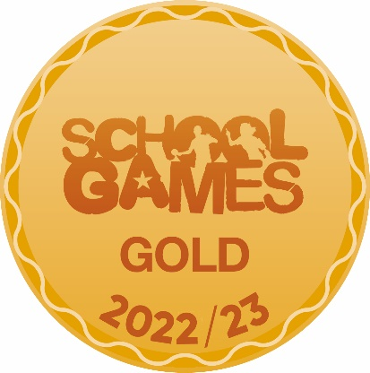

The Acorns Primary and Nursery School PE Sport Grant
Awarded 2023-2024

The Acorns Primary and Nursery School have achieved a Gold Rating in the Department for Education Healthy Schools Rating Scheme. We have achieved this by adopting rigorous systems to ensure pupils are offered the best guidance, opportunities, and support to make healthy choices and to succeed well, not only in Physical Education lessons, but as a healthy individual. We are an active school: we ensure PE lessons are active and of a high quality. Pupils are offered a wide range of after-school clubs, and we ensure there are multiple opportunities across the school day for every child to be active for at least 30 minutes. We also continue to educate our children to live safe and healthy lifestyles, whilst providing exciting opportunities to engage and inspire them within sport. We will, once again, achieve the School Games Gold Mark through our continued work with our local Schools Sports Partner. Our aim for 2023-2024 is to become a Platinum School Games School. This is an outcome of being awarded ‘Gold’ status for 5 years running.

Our Vision for 2023-2024: Our Sports Leaders will play a more active role in making everyone at The Acorns Primary and Nursery School healthier and more active. We will form stronger relationships with our PE linked Governor to ensure there is appropriate challenge and support for school sport at The Acorns. Pupils with SEND will receive a range of extracurricular opportunities.

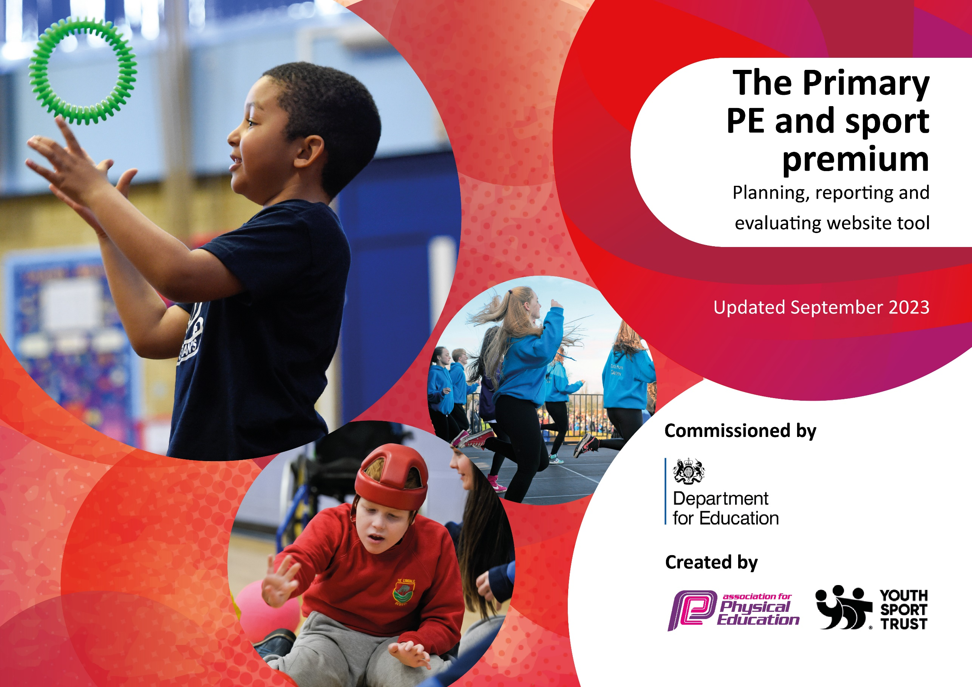

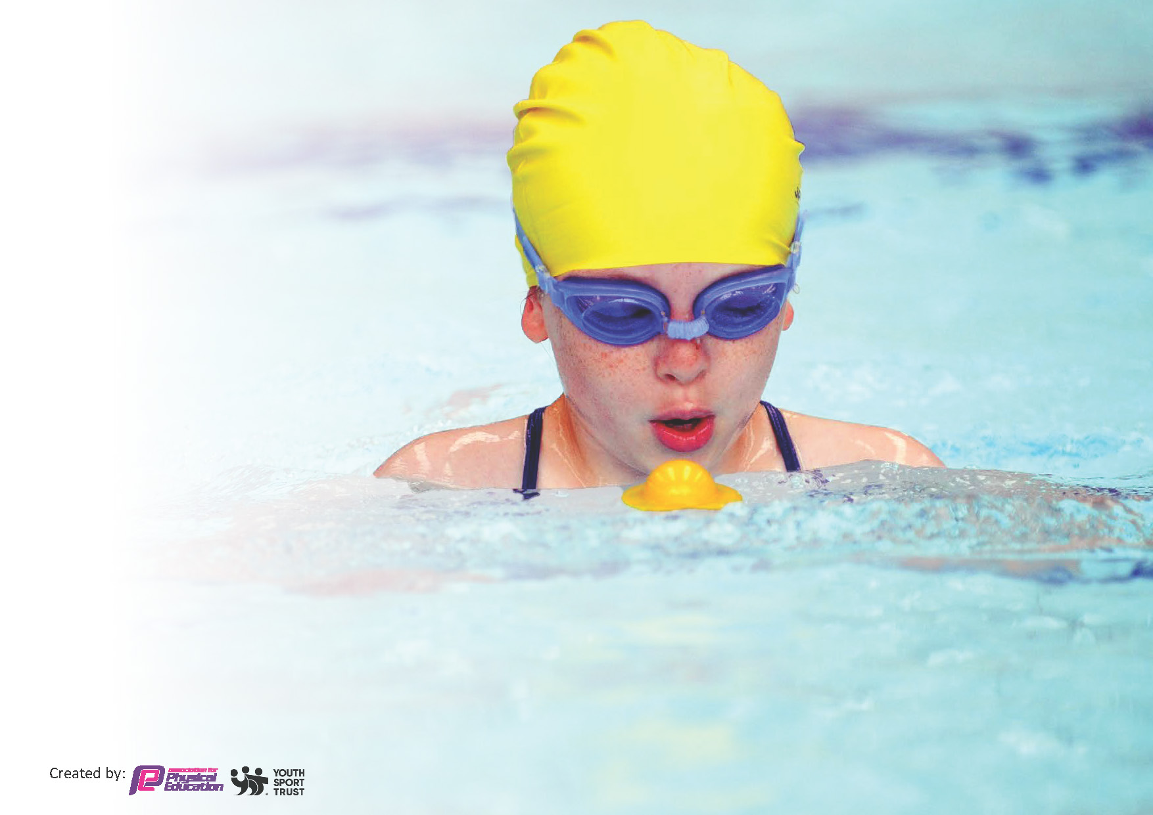
by:

Schools must use the funding to make additional and sustainable
improvements to the quality of the PE, School Sport and Physical Activity (PESSPA)
they offer. This means that you should use the Primary PE and sport premium to:

- Build capacity and capability within the school to ensure that improvements made now will benefit pupils joining the school in future years
- Develop or add to the PESSPA activities that your school already offers.

The Primary PE and sport premium should not be used to fund capital spend projects; the school’s core budget should fund these. Further detail on capital expenditure can be found in the updated Primary PE and sport premium guidance.
Review of last year’s spend and key achievements (2022/2023)

Activity/Action | Impact | Comments
We introduced a range of intervention, including growing and cooking club, to achieve a gold rating from the Healthy Schools Rating Scheme (DfE).  Inactive pupils were targeted for additional PE intervention.  Across the school year, 19 sports clubs were offered to pupils. 380 places were allocated with 59% of these being eligible for pupil premium funding and 8% of these being pupils with SEND. Pupil voice was key in the clubs we offered, as well as ensuring clubs provided pupils a pathway into competition.  All pupils in Y5&6 had access to a Moki band this year, which allowed them to track the number of steps they took each day. Pupils enjoyed finding out their total and trying to beat it the next day.  A new approach to school swimming has allowed all classes (Y3-6) to attend swimming for at least 6 weeks.  The Acorns’ partnerships with external agencies has grown further this year. We now have strong links with Cheshire Roar (girls basketball) where some of our pupils attend training sessions.  An Easter and Summer holiday club was held at The Acorns. The club allowed 30 pupils the chance to attend active and engaging holiday activities. The club is free to parents.  All staff received high quality CPD through Beth Tweddle Gymnastics.  The Acorns run a ‘Daily Mile Day’ which raised over £2500 for the school’s PTA. All pupils (rec-Y6) were involved.  The Acorns participated in 17 sports competitions, involving 180 pupils (58% pupil premium & 10% SEND) this year. This is the most we have ever entered. | We now demonstrate what is needed to be considered a ‘Healthy School’.  Pupils are making healthier snack choices and are drinking more water across the school day.  Pupils are more active throughout the school day. Not only do they receive 2 hours of high-quality PE, but they have various opportunities across the school day to be active. This includes an extensive extra-curricular program.  20 pupils received an additional 2 hours of high-quality gymnastics, delivered by a Beth Tweddle Gym coach to support their physical development and mental health. They received 7 weeks of intervention in addition to their usual PE lesson.  More pupils than ever before participated in extra-curricular sports. More Acorns pupils than ever before entered SSP competitions. Performance at competitions and events was better than ever.  Pupils are now having more opportunities to swim each year. Pupils from The Acorns participated in our very first SSP swimming gala – earning a silver medal.  More pupils, especially our most disadvantaged, have had free meals and free activity clubs to attend during school holidays  Staff feel well supported and have been up-skilled in the delivery of high quality gymnastics. All staff play an active role in the delivery of Gymnastics and have access to high quality documentation and resources.  The profile of ‘daily mile’ has been raised and is one of the interventions we offer to ensure pupils have access to 30 minutes of active time each day.  Our successes this year included finishing in 2nd place at the girls basketball comp, finishing 2nd and 3rd at the SEND bowling competition, our Y4 football team not losing a game during their competition and participating in our very first swimming gala. | Pupils had a voice in choosing after school clubs and supported staff to better understand snack choices.  Targeting our inactive population will now be a feature of what we offer at The Acorns.  Once again, after-school clubs will be linked to upcoming competitions.  Plans are in place to extend our HAF to include a winter camp, running during the Christmas break.  Our PE lead is in close contact with Brio Leisure to create a plan to increase the number of pupils engaging in regular swimming, beyond the school swimming offer we have in place.

Key Indicator 1: Increased confidence, knowledge and skills of all staff in teaching PE and sport

Action – what are you planning to do | Who does this action impact? | Key indicator to meet | Impacts and how sustainability will be achieved? | Cost linked to the action
2 hours a week over 12 weeks for 2.5 terms. PE Planning, delivery, assessment and staff CPD supported by Beth Tweddle Gymnastics  PE Teaching Resources (PE Hub)  PE Coordinator Training – ongoing through EPORTSSP  New equipment ordered to improve quality and range of PE lessons across the school (including specialist PE equipment for EYFS and SEND)  Allow staff access to high quality CPD when needed | All staff will have access to the PE CPD based on their needs. This will ensure all PE lessons are never less than good and all lessons have the equipment needed to run successfully | All PE teaching across the school is consistently never less than good  Teachers begin to lead more sessions throughout the year, building to full sessions with Gymnastics  All staff are confident in using the PE hub resources – additional training to be given by PE SL  Progression in technical, tactical and dance skills can be seen for all children in sports and dance lessons over time  Judo Education to run 6 full days of Fencing, Judo and Archery across the year |  | Beth Tweddle Gymnastics:  £4,120 for every teacher to have at least 6 weeks of CPD  PE equipment: £300 to ensure high quality PE provision  Staff specific CPD - part of EPORT SSP membership: £1300  PE Hub Membership: £350 to ensure staff have access to quality lesson plans and curriculum resources

Key Indicator 2: The engagement of all pupils in regular physical activity – Chief Medical Officers guidelines recommend that primary school pupils undertake at least 30 minutes of physical activity a day in school

Action – what are you planning to do | Who does this action impact? | Key indicator to meet | Impacts and how sustainability will be achieved? | Cost linked to the action
Free after school clubs for all pupils to ensure there are no barriers to PE engagement  Clubs to include Gymnastics, Football and Netball  Sports Coaches to be utilised to provide a huge range of opportunity for every child at The Acorns to participate  Offer high quality swimming lessons for children in years 3-6  Young leaders support adults to ensure break times are highly active  Pupils to continue to track their steps through the yearly MOKI challenge  Provide additional swimming ‘booster’ session for pupils in Y6 identified as at risk of not reaching the end of KS2 expectations  Health and well-being club to provide pupils support  Those classified as ‘inactive’ to receive additional PE lessons for a 6 week period | All pupils receive 2 hours of quality, planned and well-resourced PE lessons a week  The PE curriculum will focus on pupils becoming confident and skilled in specific sports  Breaktimes are highly active, which support pupils to reach the target of 30 mins physical activity a day  A range of ASCs are offered to meet the needs of all pupils  Pupils feel empowered by having a voice in regards to school sport  Those in need will receive a weekly well-being club, with particular focus on good diet  Those in most need of targeted support receive this | The Acorns becomes an even more active school in the areas of:  -PE Lessons  -Active break and lunch times  -CPD for Staff  -Physical and mental wellbeing  Break and Lunch times are active for all children, including those classed as ‘inactive’  Children understand the importance of daily activity and strive to ‘get their steps up!’  A wide range of extra-curricular clubs are on offer to ensure each child has a chance to participate  Signpost parents to additional swimming opportunities throughout the year  Our most ‘inactive’ pupils develop better physical literacy and a better understanding of the benefits of regular exercise |  | Free PE kit for all scheme - £500  Chester FC  £1570 – for both a Girls and Boys football club all year round  AW Coaching  £1500 – for a range of ASCs throughout the year  BT Gymnastics  £2460 – for a KS1 and KS2 gymnastics club all year round  Swimming booster sessions part of Annual EPORT SSP - £1300  Additional MOKI project equipment - £500  Young Leaders training and development through the EPORT SSP - £1300  Passion for Learning ‘well-being’ club - £1200 for a hour club each week of term time  Targeted pupil additional gymnastics sessions Summer 2 - £820
Key Indicator 3: The profile of PE and sport is raised across the school as a tool for whole-school improvement

Action – what are you planning to do | Who does this action impact? | Key indicator to meet | Impacts and how sustainability will be achieved? | Cost linked to the action
To ensure that pupils have every opportunity within the school day to be active for at least 30 minutes  Holiday clubs, run by Striker Academy, to become a regular offer at The Acorns  The Acorns are to continue to be a healthy school:  - Offer a growing and cooking club  - Use produce from school as snack / in cooking  - Healthy living a feature of the curriculum  - Healthy snack promoted  - Importance of drinking water known  Profile of PE raised through the school’s house system  Whole school initiatives provided by SGO (Mark Poole)  Our link governor is fully aware of how the PE and Sports Grant is effective spent at The Acorns | Our pupils will benefit from being regularly active and knowing the benefits of a healthy diet  Outside of term times, our pupils are supported to have active and healthy days  Pupils are inspired by meeting professional and amateur sports people  All governors should have an accurate knowledge of school sports and PE and can challenge accordingly | Work alongside Active Cheshire to ensure break times promote physical activity  Use existing facilities / resources to promote the importance of being active  Striker Academy holiday clubs will run in Easter (2 weeks) & Summer (4 weeks)  Pupils engage in additional sports events as part of their house  PE lead and link governor meet termly  Link governor observes PE lessons, reviews curriculum documentation and speaks to pupils |  | Holiday clubs: funding gained from Edsential / Packed lunches for pupils provided by PTA  Young leaders training and development as part of the EPORT SSP - £1300  Whole school initiatives, such as GULP (Give Up Loving Pop) provided as part of the EPORT SSP - £1300

Key Indicator 4: Broader experience of a range of sports and activities offered to all pupils

Action – what are you planning to do | Who does this action impact? | Key indicator to meet | Impacts and how sustainability will be achieved? | Cost linked to the action
Cheshire Phoenix to Hoops4Health Programme for KS2 children across the year  Cheshire Phoenix aspirational visit + matchday experience  Through our partnerships with Cheshire Phoenix and Chester FC, we received a season ticket pass for the year  Guest speakers to inspire pupils within sport – Athlete Visits etc…  Enrichment opportunities will be offered in a range of lesser profile sports | Pupils will be educated in holistic healthy living  Pupils and families will enjoy live sport experiences  Pupils will be enthused and inspired by professional sports visitors | Children will develop their knowledge in three areas: healthy eating, anti-smoking and basketball skills  Hoops4Health program to be run for years 3,4,5 & 6  The season ticket will allow families to experience their first Cheshire Phoenix game and Chester FC match.  Pupils have at least one moment of inspiration across the year  Pupils engage in a wide range of sports and activities outside of the PE curriculum |  | Cheshire Phoenix aspirations visit & Hoops for Health Programme: as part of SSP membership - £1300  All guest speakers to be part of SSP or funded by school sponsorships  Judo, Fencing & AW Coaching sessions - £3500

Key Indicator 5: Increased participation in competitive sport

Action – what are you planning to do | Who does this action impact? | Key indicator to meet | Impacts and how sustainability will be achieved? | Cost linked to the action
Full engagement with the Ellesmere Port School Sports Partnership  Specialist coaching in Gymnastics (2x after school clubs) and Football (Girls and Boys)  Teacher/Teaching Assistants released to attend competitions or to prepare for competitions  Parental engagement / communication continues to be strong with Sport  Sports Day (House teams) in the Summer Term to allow children to participate in inter school  sport  Pupils to receive an Acorns team kit when participating | Pupils attend ‘Celebrate’ events in order to gain a taste for a sport – these may be part of the ‘inactive’ population  Pupils to attend ‘Aspire’ events as they have attended an ASC and look to upskill  Pupils who show confidence in a particular area will access ‘Inspire’ events  All pupils engage in sports day and other house related sports activities  Pupil feel proud to represent Team Acorns | The Acorns will participate in all School Games across the year including Football, Basketball, Netball, Athletics, Gymnastics and Golf  This will be communicated with the community via school newsletters and Twitter  For all children across the school to have participated in sporting activities with a sense of competition  Every pupil who attends a competition or event goes dressed in Team Acorns kit – excluding KS1 multi-skills event |  | Engagement in SSP competitions part of EPORT SSP £1300  ASC programme – cost outlined in Key Indicator 2 – pupils who attend competition to access ASC provision  Team Acorns sports kit - £400

Key achievements 2023-2024
This template will be completed at the end of the academic year and will showcase the key achievements schools have made with their Primary PE and sport premium spending.

Activity/Action | Impact | Comments

Swimming Data
Meeting National Curriculum requirements for swimming and water safety.
Priority should always be given to ensuring that pupils can perform safe self-rescue even if they do not fully meet the first two requirements of the National Curriculum programme of study

Question | Stats: | Further context  Relative to local challenges
What percentage of your current Year 6 cohort can swim competently, confidently and proficiently over a distance of at least 25 metres? | 56% | 47% of pupils in Y6 receive pupil premium funding and are therefore classed as disadvantaged. There are many barriers to swimming our pupils face, which prevents them from regularly swimming: transport; cost of swimming; parent anxieties; pupil anxieties.
What percentage of your current Year 6 cohort can use a range of strokes effectively [for example, front crawl, backstroke, and breaststroke]? | 47% | All pupils in KS2 receive 6 weeks of swimming a year. We made this change at the start of the 2022-2023 academic year to ensure pupils swim every year for the final 4 years of their primary education. This means that for the remaining 30 weeks of the school year, some pupils have no access to swimming. 6 weeks is not sufficient enough to develop a range of strokes effectively, and we must support pupils to be able to safely swim a distance before developing a range of strokes.
What percentage of your current Year 6 cohort are able to perform safe self-rescue in different water-based situations? | 56%
If your schools swimming data is below national expectation, you can choose to use the Primary PE and sport premium to provide additional top-up sessions for those pupils that did not meet National Curriculum  requirements after the completion of core lessons. Have you done this? | Yes | As part of our SSP, we utilise the top-up swimming programme.  Our PE Subject Leader and Deputy Headteacher is working closely with Brio and our local School Games Officer to find additional ways of funding school swimming top-up provision. This will include an element of in school practical and theory-based water safety.
Have you provided CPD to improve the knowledge and confidence of staff to be able to teach swimming and water safety? | Yes | We currently have 3 members of staff who are trained to instruct swimming.

Sports Premium Total Allocation 2023-2024: £18,520.00

Signed off by:

Head Teacher: | Hannah Broom
Subject Leader or the individual responsible for the Primary PE and sport premium: | Nathan Painter  Deputy Head  Physical Education Subject Leader
Governor: | Nont Iamkamphaeng
Date: | 20/09/23

