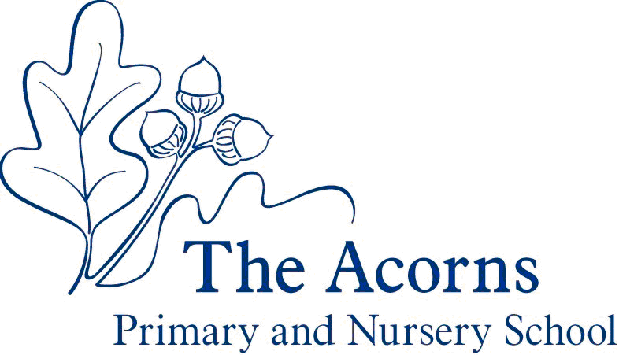
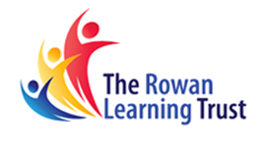

Acorns to Oak Trees

The Acorns Primary and Nursery School
Acorns to Oak Trees:
A Graduate Award Program for pupils at The Acorns

Acorns to Oak Trees:

A Graduate Award Program for Acorns pupils

Dear parents and pupils,

We are delighted to share our Acorns to Oak Trees Graduate Award program. It has been written with our pupils and for our pupils. It is unique to The Acorns and offers experiences and achievements that go beyond the National Curriculum.
Why have a Graduate Award Program?
- To make our curriculum even more exciting and geared to what our pupils like to do and learn
- To help pupils to develop characteristics of effective learning that are used across school and life
- To encourage pupils and families for supporting our ethos
- To make our school an even better place to learn
- To help pupils contribute to our school, their family and the local community
- To give our pupils a rich and varied diet of experiences
- To involve parents in their children’s development

Two Mirrored Aims
- Develop personal skills, health, wellbeing and knowledge to make a contribution to our school community, and our local community
- Understand and enjoy our school and local community, and in doing so, develop personally by valuing and respecting others

Rich experiences
Every year, pupils will enjoy new challenges and develop skills in exciting ways. It could be singing to residence at a local care home, building a campfire and experiencing a sunset, performing to an audience or enjoying a trip to the theatre.
The booklet that follows sets out the experiences on offer. You will see that we need your help if children are going to succeed and gain the full benefit of the program. The experiences that are perfect to do at home are highlighted
Tracking Progress
At three points across the year pupils will reflect on the experiences they have had, and those they are looking forward to. In July, pupils will look ahead to their next year and the experience they will have access to; December will allow a look at what has been done in Autumn Term and look forward to which experiences they have left to do; June will allow pupils the chance to review their year.
The experiences that we offer are centred around further development of our Characteristics of Effective Learning.
We want our pupils to be able to:
- Be confident and ready to try new things
- Be respectful to those around them, in school and in the wider community
- Know how to stay safe
- Be health-conscious, eat well and stay active, swim and compete in sports
- Perform or sing a simple piece of music, dance and drama and appreciate others’ work
- Design and make artistic and practical objects and appreciate others’ work, including work of celebrated artists and architects
- Learn with increasing independence and have ambition
- Show empathy and understanding of others in school, at home, in our town, our country and overseas
- Know what is happening in the wider world and express an opinion on current affairs
- Speak clearly and confidently using Standard English
- Read well, for pleasure, for study and for information
- Communicate in well-written, grammatically correct, accurately spelt sentences and paragraphs
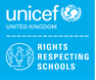
- Use numbers confidently to solve problems when studying and in daily life

We are a Rights Respecting School with No Outsiders

Article 29: Education must develop every child’s personality, talents and abilities to the full. It must encourage the child’s respect for human rights, as well as respect for their parents, their own and other cultures, and the environment.

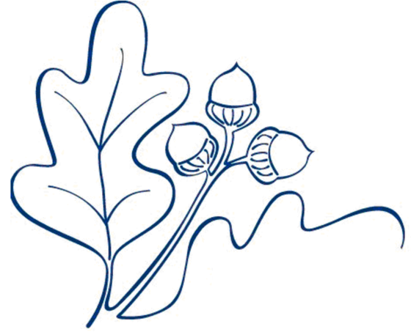

- Take part in a treasure hunt
- Visit a farm
- Go on a minibeasts hunt
- Do some gardening
- Attend a teddy bears’ picnic

- Play a game of hide and seek
- Make a daisy chain
- Serve snack to my friends
- Tidy up after a mealtime
- Attend my first school trip

- Write invites to a party
- Care for a class pet
- Plant bulbs & herbs
- Create a bug hotel
Be the Best You Can Be
Nursery

- Make a time capsule
- Share a story at a residential care home
- Complete the Daily Mile
- Have a picnic outside

- Fly a kite
- Complete a jigsaw
- Listen to music
- Cook a meal for my family or friends
- Have a water fight
- Make a musical instrument
- Try food from a different culture
- Bake a cake
- Make a dessert

Be the Best You Can Be
Reception

- Learn about a local charity
- Raise money for charity
- Travel on a public train, bus or boat
- Visit the beach
- Play a board game

- Write a letter and post it
- Enjoy a campfire
- Climb a tree
- Walk in a forest / wood
- Perform to an audience
- Make my own sandwich
- Listen to live music
- Learn lines in a play
Be the Best You Can Be
Years 1 & 2

- Prepare food for others
- Visit a place of worship
- Visit a pond
- Watch a play
- Pick up litter in my local area
- Visit a farm or zoo
- Learn to tie my shoelaces
- Visit a library and borrow a book
- Compete in a sports event
- Sing to an audience

- Build a den
- Visit a national landmark
- Use a pupil transport system
- Cross a famous bridge
- See a theatre show
- Visit an art gallery

Be the Best You Can Be
Years 3 & 4

- Complete a curriculum homework project challenge
- Learn lines and perform them in front of an audience
- Learn about a job / career
- Learn some first aid skills
- Grow my own fruit or veg

- Participate in bird watching
- Read books from 5 authors who are new to me
- Do the washing up
- Walk to the top of a hill
- Watch a sunrise / sunset
- Learn to ride a bike
- Go rock climbing
- Help someone in the community
- Play a musical instrument
- Lead an activity for a younger child
- Help to improve my school
- Strip and make my bed
- Take part in a team quiz
- Use a compass and a map

Be the Best You Can Be
Years 5 & 6

