The Acorns Primary and Nursery School PE Sport Grant
Awarded 2020-2021

Total number of pupils on role (KS1 & KS2) |  |  |  | 261
Lump sum |  |  |  | £16,000
Amount SG be offered per pupil (£10 per child) |  |  |  | £2,610
Total amount of Sports Premium be offered  + short fall from 2019-2020 |  |  |  | £26,104.38
Our Vision for 2020-2021:

Our vision this year is clear. Acorns will remain an active school despite the challenges we have, and will continue to face. We will continue to work with our close partners when it is safe to do so. We will ensure that there are multiple opportunities across the school day for every child in the school to be active. We will also continue to educate our children to live safe and healthy lifestyles.

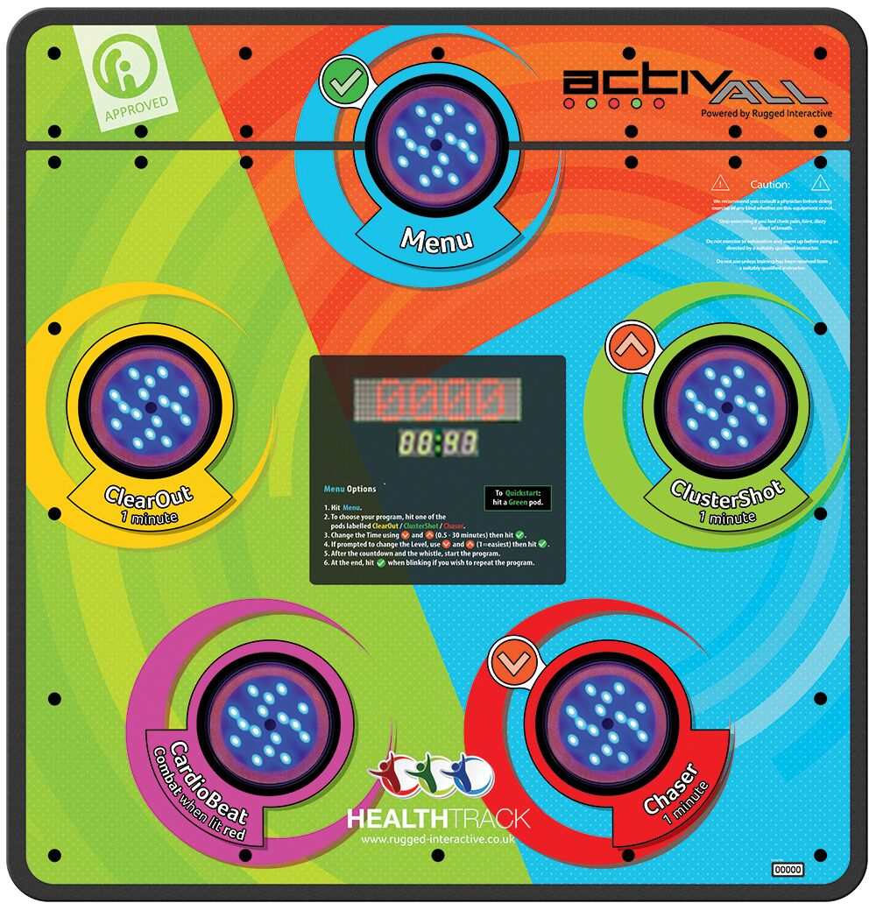

Action Plan:

Due to the COVID-19 worldwide pandemic causing a ‘part-closure’ of school, many of the proposed plans did not happen last academic year. This left a 7,494.38 short fall. This has been added to the total amount for this academic year.
Impact: Please note that due to COVID-19 guidelines and restrictions, many actions were unable to be implemented and therefore had no impact on this academic year. These actions will be revisited in the upcoming year.

Objective One: | Actions: | Desired Outcome: | Cost: |  | Impact:
Ensure that all children have access to at least 30 minutes of physical activity each day | Partnership with Active Cheshire to ensure new initiatives are embedded at The Acorns  Active Cheshire to also work with The Acorns’ Sports Crew to ensure they are fulfilling their role during active play and lunch times  Purchase of 3x Activall interactive activity boards to be placed in areas around school to support active break/lunch times  Introduce the ‘pedometer challenge’ across school | The Acorns becomes an even more active school in the areas of:  - PE Lessons  - Active break and lunch times  - CPD for Staff  - Physical and mental wellbeing  Active Cheshire will support in improving the playground accessibility and equipment (Autumn Term)  Break and Lunch times are active for all children, including those classed as ‘inactive’  Boards placed in KS1 and KS2 playgrounds, as well as the Studio Hall to allow access for before and after school club  Children understand the importance of daily activity and strive to ‘get their steps up!’  This will become part of the school’s ethos and weekly / termly winners will receive additional sports coach sessions as well as recognition on Twitter | Active Cheshire Gold Subscription:  £2000  Payment on hold until Summer Term 2021  Summer term- NOW PAID  3x Activall Interactive activity boards: £6,300  Pedometers: £100 |  | Due to Covid guidelines, Active Cheshire were unable to come in and support with our goals.  They have moved this into 2021-22 when we can start to allow visitors and outside agencies back in.  Children very engaged with activity boards, particularly on the playground. It has developed communication and competitive attitudes. They have provided an extra activity for playtimes for children who may struggle with imaginative games.  Pedometers were well received throughout the school. Less active children thrived to get the steps up and classes were awarded sports coaches and an activity of their choice. Wristbands have now been purchased instead of pedometers as they will provide more statistics for the children.
Increase in participation rates in after school clubs – Ensure that at least 50% of children have extra-curricular sporting opportunities each week – 10% of these from the non-active population | Free after school clubs  Review to take place half-termly to decide when extra-curricular after school after school clubs can resume at The Acorns  Sports Coaches to be utilised in Summer Term to provide a huge range of opportunity for every child at The Acorns to participate | A wide range of extra-curricular clubs are on offer in Summer Term to ensure each child has a chance to participate | Amount allocated to ensure a wide range of extra-curricular clubs run: £3,000 |  | N/A
Increase participation and success in competitions within school sports, including in the virtual School Games | School Games challenges will be delivered within PE lessons and results will be posted to the school’s SSP  Sports Day in the Summer Term to allow children to participate in inter school sport. | The Acorns will participate in all School Games across the year  This will be communicated with the community via school newsletters and Twitter  For all children across the school to have participated in sporting activities with a sense of competition. | N/A  Alternative Sports Day activities with support from Active Cheshire & Streetwise Soccer- £745 |  | So far, The Acorns has finished in 2nd (Hockey) and 1st (Rugby) position in School Games across Autumn Term - a huge achievement! Spring and Summer games were participated in also across all of KS2.  Sports Day 2021 will incorporate ‘alternative’ activities to provide a positive and fun day for all children within their transition days. Unfortunately, there will be no spectators this year but lots of fun for the children and of course, an element of competition.
Strengthen subject knowledge, pedagogy, and teaching | 2 hours a week over 12 weeks for 2 terms. PE Planning, delivery, assessment and staff CPD supported by Beth Tweddle Gymnastics and – staff to team teach and develop skills with coaches – staff and coach to produce support progression document each term  PE Teaching Resources (PE Hub)  PE Coordinator Training – ongoing through COAKSSP  New equipment ordered to improve quality and range of PE lessons across the school (including specialist PE equipment for EYFS and SEND)  Allow staff access to new sports within PE lessons  To introduce ‘Forest School’ outside learning | All PE teaching across the school is consistently never less than good  Teachers begin to lead more sessions throughout the year, building to full sessions with Gymnastics  All staff are confident in using the PE hub resources – additional training to be given by PE SL  Progression in technical, tactical and dance skills can be seen for all children in sports and dance lessons over time  Judo Education to run 6 full days of Fencing, Judo and Archery across the year | Beth Tweddle Gymnastics - £2,000  Judo Education: £2,000  PDS: £2,000  PhysEd Solutions: £1000  PE equipment order: £1,800  Part of EPORT SSP: £1,200  PE Hub Membership: £350  Cheshire Wildlife Trust (Forest School): £3,600 |  | Across the Summer Term, 4 classes participated in gymnastics led by BT Gymnastics. Teachers were able to team teach and develop their knowledge and skills within Gym. PDS also provided a dance coach across Summer Term in which 2 classes benefitted.  The PE Hub has been well utilised with teachers and support staff using units of planning for each allocated sport. Easy to follow with clear progression outlined made it a helpful and valued investment.  Regular PE Coordinator meetings were attended virtually and regular updates and support provided online by the EPORT SSP.  PE equipment was replaced or replenished with class sets of footballs, rugby balls, basketballs and netballs being purchased. New equipment such as dance props and table tennis equipment was purchased to expand the range of sport available. All teachers were able to teach lessons with a good level of equipment.  Children were introduced to new sports including archery and judo by specialist coaches throughout the year. This was well received by all and provided new experiences.
Increase children’s knowledge about leading a healthy life | Cheshire Phoenix to Hoops4Health programme for KS2 children across the year  Sports coaches to support cross curricular links  Oral Hygiene workshops for all KS2 children | Children will develop their knowledge in three areas: healthy eating, anti-smoking and basketball skills  Hoops4Health program to be run for years 3,4,5 & 6  Healthy class of the week competition across the school – children to receive additional play time on Fridays  Visits from Active Cheshire to KS1 promoting healthy living  PDS coaches to support teaching within science regarding being healthy in KS1. | Hoops4Health Program: £360  PDS coaching cross curricular workshop: £100  Oral Hygiene workshops across KS2: £660 |  | During Science, KS1 classes were supported by PDS coaches to understand the effect of being healthy. This made solid cross-curricular links for our children and supported teachers in delivery of lessons.  All KS2 children took part in Oral hygiene workshops. This promoted the importance of good oral hygiene and how to implement this daily.
Improve achievement in swimming | Offer high quality swimming lessons for children in years 3 and 4  Ensure staff are qualified to support Brio swimming instructors  Track those children and report once they reach the end of KS2 | Allow one member of staff to complete the level 1 and 2 swimming instructors course allowing them to lead small group swimming and support other members of staff to do this  Provide information for how parents can support children in their swimming beyond their time at The Acorns  Signpost parents of children who are eligible for Pupil Premium to free swimming for a year at the EPSV | Additional Swimming Booster sessions as part SSP for Y6  Additional booster swimming sessions for those who missed due to local/national lockdowns: £2,000 |  | Pupils in Year 4E and Year 3/4T attended swimming for an average period of 6-8 weeks. In this time, all children who attended were involved in a 30-minute swimming lesson weekly with either a qualified member of staff from The Acorns or a swimming instructor from the EPSV. Children in Year 3M will be able to swim in the upcoming academic year. All children made progress in this short period of time and achieved at least Level 1.
Total |  |  | Total: £23,855  Shortfall to carry over to 2021/2022: £2,249.38

