Acorns Assessment Results 2023

Expected Standard |  | End of Key Stage 1 |  | End of Key Stage 2
 |  | 2022 | 2023 | 2022 | 2023
Reading |  | 62% | 53% | 71%  103 | 61%  102
National |  | 67% | 69% | 75%  105 | 73%  105
Disadvantaged |  | 57% | 50% | 69%  101 | 54%  100
Non-Disadvantaged |  | 68% | 57% | 84%  104 | 75%  105
Girls |  | 59% | 56% | 90%  106 | 67%  103
Boys |  | 66% | 52% | 61%  100 | 53%  100
Writing |  | 31% | 47% | 69% | 75%
National |  | 58% | 61% | 69% | 71%
Disadvantaged |  | 28% | 32% | 60% | 67%
Non-Disadvantaged |  | 36% | 61% | 78% | 92%
Girls |  | 31% | 50% | 81% | 81%
Boys |  | 33% | 45% | 57% | 67%
GPS |  | NA |  | 71%  104 | 64%  103
National |  |  |  | 72%  105 | 72%  105
Maths |  | 51% | 62% | 60%  102 | 75%  102
National |  | 68% | 71% | 73%  104 | 73%  104
Disadvantaged |  | 52% | 55% | 65%  99 | 67%  101
Non-Disadvantaged |  | 50% | 70% | 84%  105 | 92%  105
Girls |  | 50% | 63% | 81%  102 | 71%  102
Boys |  | 52% | 62% | 66%  102 | 80%  103
Combined |  | 31% | 38% | 52% | 47%
National |  | NA | 57% | 59% | 59%
Disadvantaged |  | 28% | 23% | 60% | 33%
Non-Disadvantaged |  | 36% | 52% | 78% | 75%
Girls |  | 31% | 38% | 81% | 48%
Boys |  | 33% | 38% | 57% | 47%
Progress KS1 to KS2 | Reading |  |  | +0.7 | - 0.1
 | Writing |  |  | +0.5 | +2.9
 | Maths |  |  | +0.9 | +1.6
Higher Standard |  | End of Key Stage 1 |  | End of Key Stage 2
 |  | 2022 | 2023 | 2022 | 2023
Reading  National  Disadvantaged  Non-Disadvantaged  Girls  Boys |  | 7%  18%  0%  15%  4%  9% | 4%  0%  9%  6%  3% | 12%  28%  13%  13%  23%  5% | 17%  13%  25%  24%  7%
Writing  National  Disadvantaged  Non-Disadvantaged  Girls  Boys |  | 2%  8%  0%  4%  0%  5% | 0% | 7%  13%  4%  10%  10%  5% | 8%  4%  17%  5%  13%
Maths  National  Disadvantaged  Non-Disadvantaged  Girls  Boys |  | 11%  15%  5%  18%  9%  14% | 4%  0%  9%  0%  7% | 24%  23%  17%  37%  33%  19% | 6%  4%  8%  5%  7%
Combined  National  Disadvantaged  Non-Disadvantaged  Girls  Boys |  | 2%  NA  0%  4%  0%  5% | 0% | 2%  4%  2%  5%  10%  0% | 0%

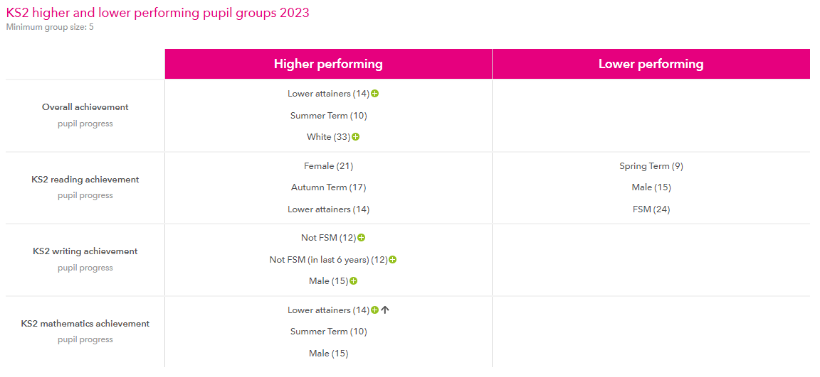

 | KS1 Phonics Screening Check
 | 2022 |  | 2023
Year 1  National | 64%  75% |  | 71%  81%
Year 2 Retake  National | 33%  87% |  | 81%
Early Years Good Level of Development
 | 2022 | 2023
School  National | 58%  65% | 58%  68%

Y4 Multiplication Check
2022 | 2023
School Mean Average Score = 17.0  National mean average score = 19.8  School Score of 25 (full marks) = 19%  National Score of 25 (full marks) = 27% | School Mean Average Score = 21.5  National Mean Average Score = 20.5  School Score of 25 (full marks) = 32%  National Score of 25 (full marks) = 33%

